Unit Plan (Stage 1 Mathematics, Topic 8: Geometry)

Overview

In this topic the difficult topic of mathematical proof is addressed. The geometry of circles is also addressed, and circle theorems are used to illustrate mathematical proof. Electronic technology (mostly GeoGebra) is used to help explore and form hypotheses about the properties of circles (and the geometric properties of lines and polygons drawn inside circles). Examples and counterexamples are used to further critique hypotheses, and finally mathematical proof (direct, contradiction, contrapositive, and maybe some others) is used to prove hypotheses. Through this process the students will be exposed to the circle theorems and proofs thereof. They will also be exposed to the concept that although a proof can be correct, it is not necessarily the only proof: there are multiple ways to prove the same theorem. The students should also be provided with plenty of opportunities to discover some circle theorems for themselves, and this will be extended in the summative investigation task in which they will be asked to investigate the geometric properties of circular inversion.

Required Knowledge

There are a number of concepts that the students will need to be confident with to succeed in this unit, the main ones are:
- Angle Notation, “∠ABC”.
- Properties of isosceles triangles.
- Properties of right triangles.
- Sum of the internal angles of a triangle.
- Similarity and Congruence (of triangles).
The students may also have already been exposed to the concept of mathematical proof as it may have been introduced to them beforehand, and depending on their familiarity with the concept more or less time might need to be spent on the basic principles of proof (Step by step working with each step given justification, the idea of proof by contradiction might be new to them, etc.).

To gauge students prior knowledge, I’ve prepared a set of interactive slides in which they can participate by completing a quiz and answering some questions about their prior knowledge (see a layout of this quiz here: https://www.mentimeter.com/s/4f332bde8bd2710b4d1b00f8c8957291/e458474a8aee). I would incorporate this quiz into the first lesson of the unit (see Lesson 1 below in the Unit Schedule), and I would preface it by explaining that the quiz is to determine if I should explain these required background topics first, or if I should skip past them leaving more time for other things later in the unit. if the results are unclear I would just go through the required prior knowledge anyway just to ensure everyone was on the same page, but if there was overwhelming consensus that the whole class was already familiar with any of the ideas listed above, then I would skip them and get straight into the circle theorems, potentially leaving more time at the end of the unit to work on the summative investigation.

Learning Intentions
I hope that students completing this unit should come out of it with:
- Confidence to explore geometric properties of shapes, both using electronic technology and otherwise, and to form hypotheses about what such properties might be.
- Some ability to attempt proofs of such geometric properties (Subtopic 8.2: The nature of proof).
- Knowledge of the geometric properties of circles (Subtopic 8.1: Circle Properties is SACE Subject Outline):
- Radius and tangent at the circumference are orthogonal.
- Length of two tangents from an external point are equal.
- Alternate segment theorem.
- Angle subtended at the centre is twice that at the circumference.
- Angles subtended at the circumference by the same arc are equal.
- Opposite angles in a cyclic quadrilateral are supplementary.
- An angle subtended by a semicircle is a right angle.
- Chords of equal length subtend equal angles at the centre.
- Intersecting chords theorem.
- Converses of the above.

Unit Schedule (Topic 8: Geometry, Stage 1 Mathematics)
My intention for this Unit is to show the students a few examples of a number of different types of proof, and as part of that process get them to explore and hypothesise about the circle properties we are proving. Exercises should help familiarise them with the properties and how to apply them.

The bulk of the unit will be going through the circle properties, one at a time. For each property I would go through the same (or similar process) of:
- Get the students to explore the property using technology, and suggest/ hypothesise about them.
- Test their hypotheses by looking for counterexamples.
- Showing them a proof for the property.
For that part of the unit, I’ve made a graphic organiser for the circle properties and required knowledge on prezi (https://prezi.com/view/vpmCHdeFbIV2xlYHhZiK/), this essentially shows one possible dependency graph for a sequence of proofs, see additional materials below for the particular proofs I had in mind. In the Unit Schedule below is a proposed sequence of lessons for going through this material, where lessons involving this part of the unit (Lessons 2-5) have images of the graphical organiser in which geen shows topics to be covered in that lesson, and grey shows topics that should have already been covered. There is quite alot of flexibility however in terms of the sequence in which they can be taught, and if students show interest in a particular area then I would change the sequence to match their interest. The proposed sequence of lessons below is also very condensed, it is likely that going through these topics will take longer than the expected 5 lessons here, and that is ok. If students are confident with the prior knowledge to begin with that would take out about a lesson worth of revision, and even if that is not the case if the covering of the circle properties spills over into Lessons 6-7 that should still leave plenty of time for the summative investigation. The things that might get sacrificed (with less time spent on them in that case) would be the converse theorems and alternate proofs, which are potentially less crucial --- the converse theorems could be left as exercises (with worked examples provided) and the alternate proofs could potentially be skipped entirely. Again if students ask for or show interest in alternate proofs (or are struggling to understand the first proof) then I would go into them but if not I would skip them if I was pressed for time.
Week | Lessons
6 | Lesson 1:  Introduction to Topic.  Pre-quiz: https://www.mentimeter.com/s/4f332bde8bd2710b4d1b00f8c8957291/e458474a8aee  Introduce the concept of proof.  Give a Topic Overview:  - Give introduction to the process by which we will go through the circle properties (1. Explore using GeoGebra, 2. Propose Hypotheses, 3. Test Hypotheses using examples and counterexamples, 4. Proof).  - Show the sequence of circle properties we will do via the Prezi graphical organiser (https://prezi.com/view/vpmCHdeFbIV2xlYHhZiK/),  - Preview the summative investigation task (Apply the above investigative process to something new).  Lesson 2:  Review any additional material indicated to be needed in the pre-quiz.  - Angle Notation, “∠ABC”.  - Properties of isosceles triangles.  - Sum of the internal angles of a triangle.  - Triangle Inequality  - Similarity and Congruence (of triangles).  Introduction to some circle properties (first getting students to play with GeoGebra animated/ interactive constructions and maybe suggest hypotheses, then presenting the properties, and finally showing examples of proofs):  - Length of two tangents from an external point (are equal) (nice easy direct proof to get started).  - Radius/ Tangent property (orthogonal) (use as an example to introduce proof by contradiction)  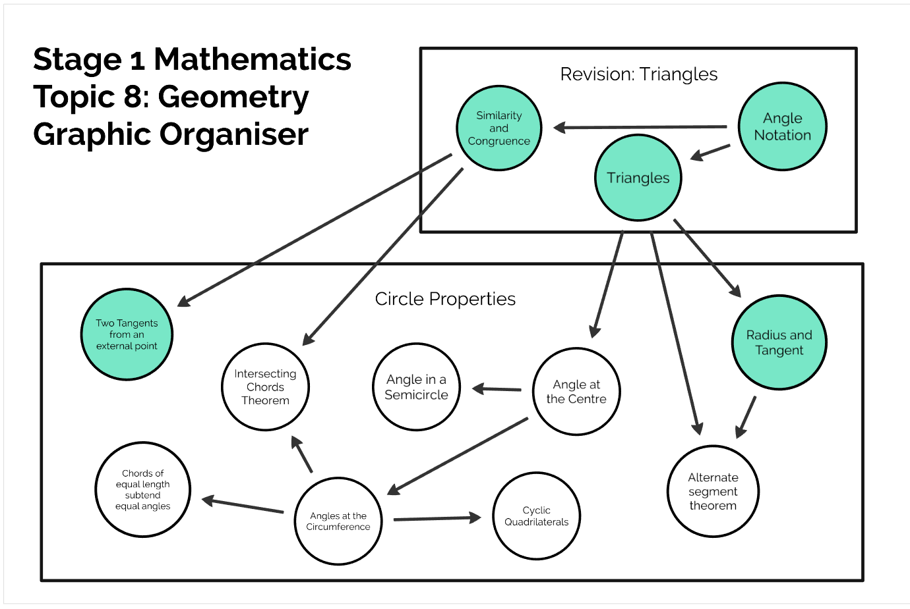
7 | Lesson 3:  - Angle at the centre is twice that at the circumference  - Angles at the circumference subtended by an arc are equal.  - Angles subtended by a semicircle are right angles.  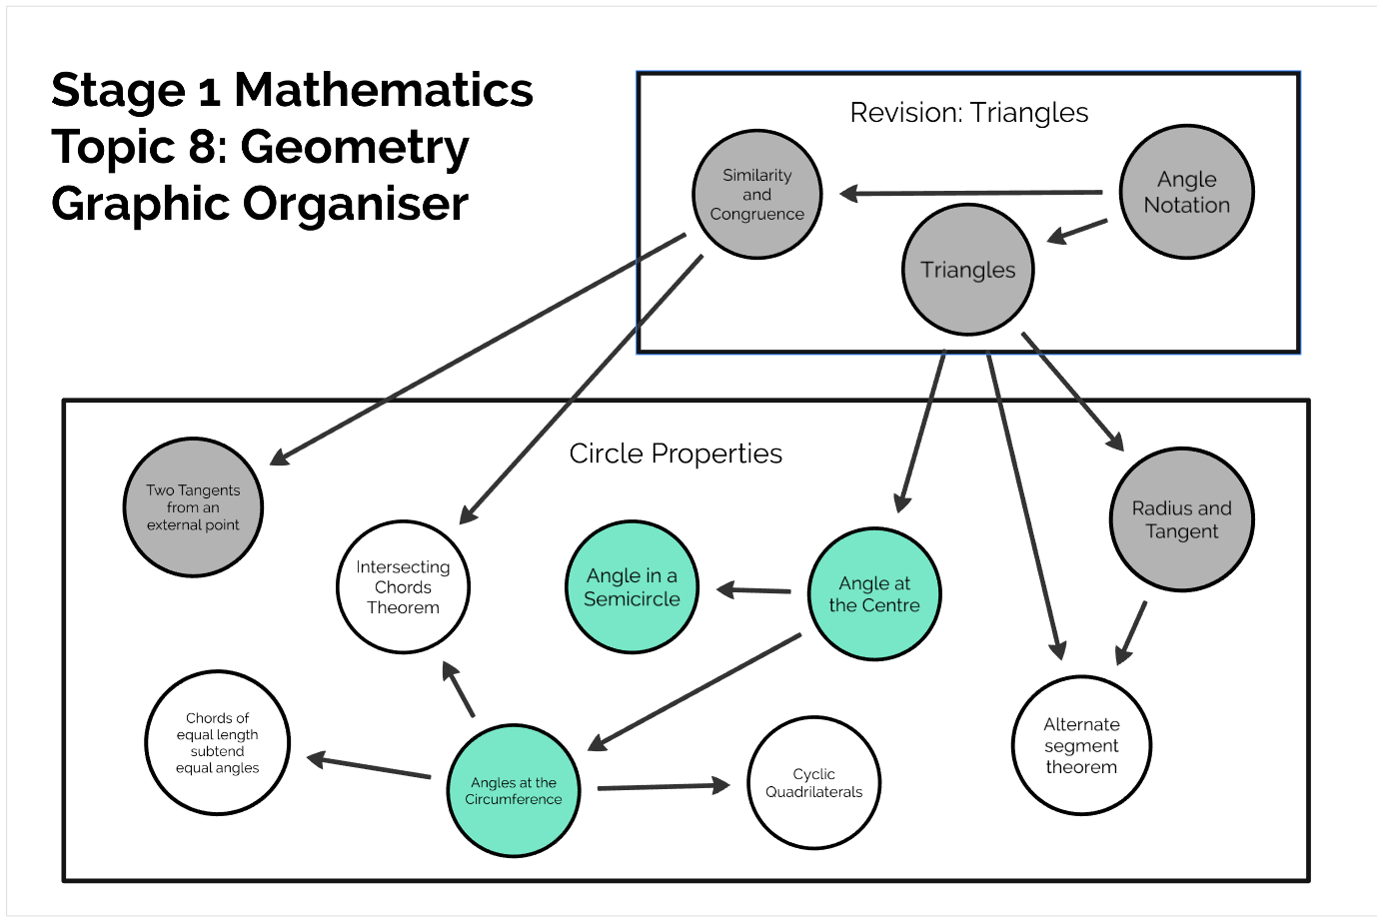  Lesson 4:  - Opposite angles of cyclic quadrilaterals are supplementary.  - Chords of equal length subtend equal angles  - Alternate segment theorem  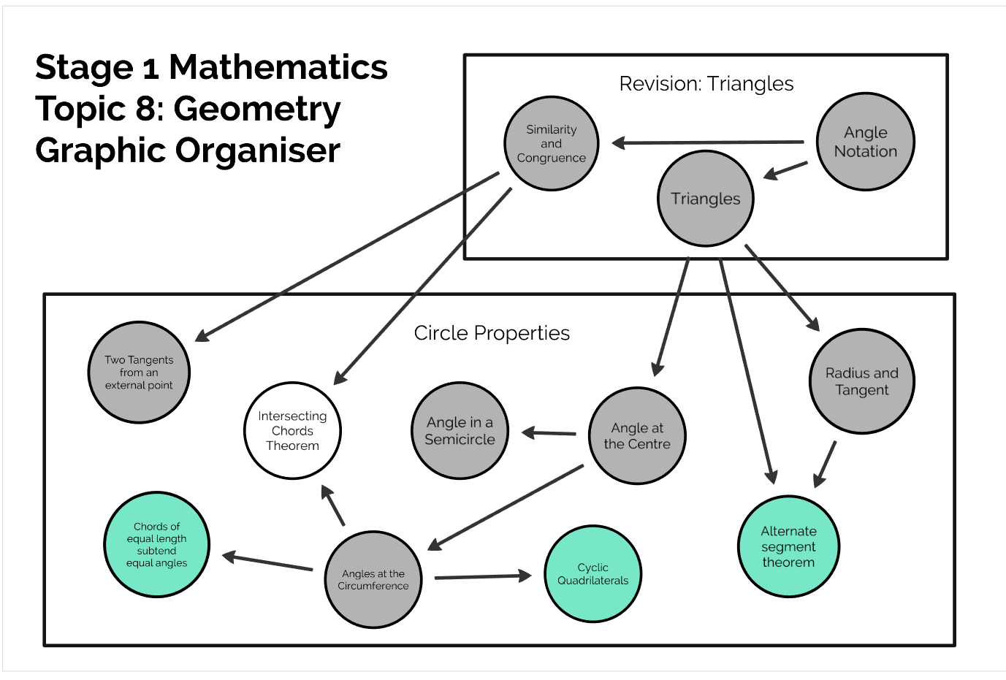
8 | Lesson 5:  - Intersecting Chords Theorem  - External Intersections  - Tangent and Chord Special Case  - Discuss Converse Theorems, and  - Alternate Proofs of Theorems covered already.  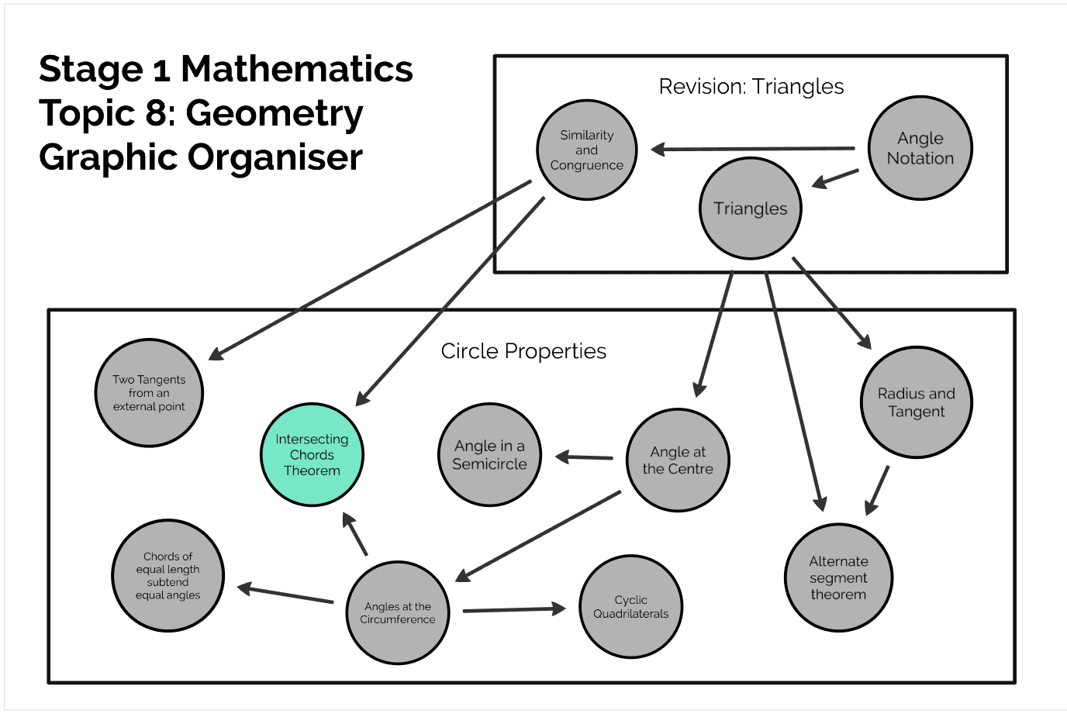  Lesson 6:  - Discuss Converse Theorems, and  - Alternate Proofs of Theorems covered already.  - Work through worksheets of proof questions and geometry properties.  - Begin guiding Summative Investigations.
9 | Lesson 7:  - Identify specific problem points via a poll to identify particularly problematic concepts and revisit these concepts and provide alternative explanations/ different perspectives to help understand them. I leave this deliberately open to allow it to be informed by the formative assessment.  - Discuss Converse Theorems, and  - Alternate Proofs of Theorems covered already.  - Guide Summative Investigations  Lesson 8:  - Discuss Converse Theorems, and  - Alternate Proofs of Theorems covered already.  - Guide final decisions on Summative Investigations

Assessment and Evaluation
There are only two lessons in this unit dedicated to formative assessment, the initial pre-quiz in Lesson 1 targeted at assessing prior knowledge and the poll in Lesson 7 targeted to assess problem points in the material taught in this unit to spend additional time on. However the intention is that alot of the work and exploration will be done by the students via online interactive worksheets through GeoGebra or similar and this would allow continual monitoring of their progress, and the lessons should be adapted in speed and depth to move through the material quicker and in less depth if the students are finding the material easy, and slower and in more depth, with explanations provided from more perspectives (alternate proofs and such) when students are struggling. The final (summative) assessment for the unit will be via the Circular Inversion investigation, see attached.

Technology Requirements

This unit does assume that every student will have access to an internet-enabled device during classes. Preferably a tablet or laptop computer, although smartphones will suffice. When designing this unit I had in mind the context of the Valley View Secondary School in mind (http://www.valleyview.sa.edu.au/) which has recently (as of 2018) instituted a laptop policy from year 10 onwards (at least), so I thought that was reasonable as this is a slightly below average socio-economic DECD school. However if this technology requirement was not met, this unit could be adapted to not require technology, the pre-quiz and poll could be done with physical handouts, proofs could be given on the whiteboard, and physical models could be constructed to play with geometric properties. It would be more difficult to teach though, for sure. For the summative assessment I think it is fair to assume students will have access to internet-enabled devices, either through a school library/ computer suite or at home.

Additional Resources

Additional resources used in this unit include:
- Prezi Graphical Organiser: (https://prezi.com/view/vpmCHdeFbIV2xlYHhZiK/)
- Summative Assessment Task Sheet (Investigation: Circular Inversion, see attached).
- Pre-Quiz: (https://www.mentimeter.com/s/4f332bde8bd2710b4d1b00f8c8957291/e458474a8aee)
- The lesson plan I made is also relevant (roughly matches to Lesson 3 in the Unit Schedule above). Note this lesson plan could be improved (feedback from Ian also in the link), and the comments about the assumed knowledge where actually useful in constructing this Unit Plan. Link: https://armadilloa16.github.io/eportfolio/mteach/mathcm/2018/02/28/maths-lesson-plan.html

Proofs I had in mind when constructing the dependency graph shown in the prezi graphical organiser were:
- Radius and Tangent: https://www.khanacademy.org/math/geometry/hs-geo-circles/hs-geo-tangents/v/proving-radius-is-perpendicular-to-tangent-line
- Two Tangents from an external point: follows simply from congruence of triangles by adding in two radii of the circle to the two points where the tangents touch the circumference of the circle. Also if you do the Radius and Tangent property first you even know that these triangles will be right triangles, although that is not needed for the proof it does make it slightly simpler.
- Angle at the Centre: http://amsi.org.au/teacher_modules/Circle_Geometry.html#Angles_at_the_centre_and_circumference
- Angles at the Circumference follows from Angle at the Centre simply by uniqueness of the angle at the centre.
- Angle in a Semicircle follows as a special case of Angle at the Centre.
- Cyclic Quadrilaterals: My video task shows this one (https://youtu.be/zUL2OBqF-qQ)
- Alternate Segment Theorem (https://brilliant.org/wiki/alternate-segment-theorem-2/)
- Chords of Equal length subtend equal angles follows by symmetry (rotation). Alternately this can also be easily shown by using similar triangles. I think this is an appropriate proof to try and get the class to do (it would still potentially be challenging, given the vagaries of “What exactly is a proof” but still, it is a straightforward one).
- Intersecting Chords Theorem: This one is probably the hardest of the lot (in my opinion), not in terms of difficult to prove, but in terms of dificult to understand. The special cases bend the mind a little too. My proof of preference is the one on the wiki page: https://en.wikipedia.org/wiki/Intersecting_chords_theorem, which simply uses angles at the circumference to show the two triangles are similar, and then uses similarity to prove the intersecting chords theorem.

Summative Investigation Task
See attached for the Circular Inversion Investigation Task.

